Drupal Manual

The current theme is called “Black and Green Contemp”, even though it is not black and green.

Logging in and making basic edits

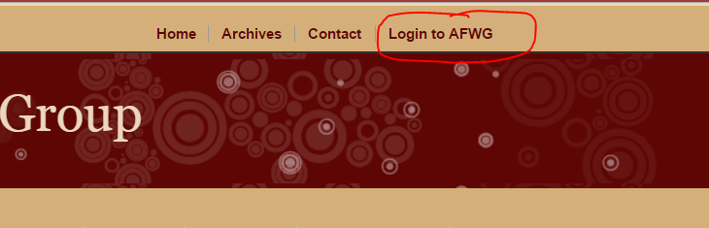

1. Use the credentials from the Passwords.docx to log in.
2. For pages that you would like to edit, navigate to the page using the visual navigation bar.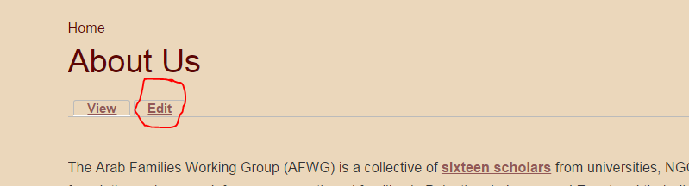
3. Right below the pages title, there should be an “Edit” option. Click this option and you will see an internal editing environment, were you can change text/headings/links/images and etc.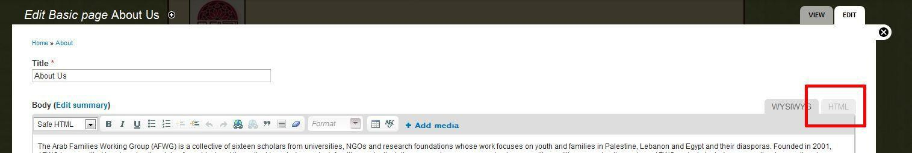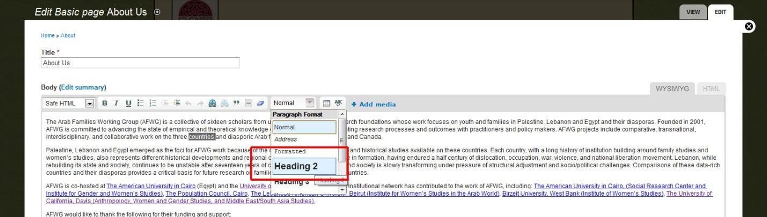
4. You can use the “Headers” option to make text bigger.
5. **IMPORTANT!** Be very careful when editing any page that uses a toggle function to make text appear or disappear. If you must edit this content, and a developer is unavailable, click the “HTML” button at the top right of the text editor. This will display the code of the page, and you can go in and find the text you want to edit. (Just be careful not to edit or delete any code).
6. LinksClick the button that looks like the Earth with a little chain-link at the bottom. A small pop-up box will appear. Insert the URL information, then save the link. You can edit the text afterwards.
7. Images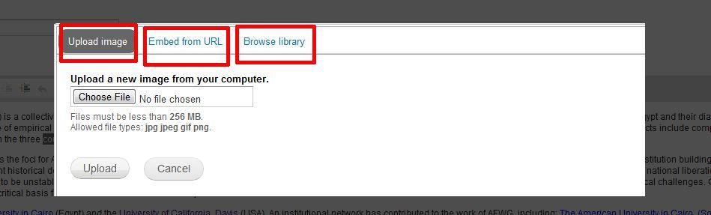In the pop-up menu, click **Browse** to select an image to upload from your computer. You can select the **Embed Image/Video** tab to add a Youtube video or **Browse Library** to add existing assets.
8. When you are done making changes, click “Save” at the bottom left of the page.

Adding Non-text Elements to a Page

1. Go to: Structure > Blocks
2. Check to make sure that you are editing blocks on the correct theme.
3. Add a rotating banner or a block by clicking the appropriate link above the table.
4. Edit the block as you please.
5. When you are finished, under “Block Location”, select where on the page you would like the block to appear.
6. Under “Visibility Settings > Pages”, make sure to select where you would like the block to be displayed.
   1. For global blocks, leave as is.
   2. For blocks appearing only on specific pages, select “Only the listed pages” and follow the instructions provided on how to supply the pages.
7. Save the block. It should route you back to the Blocks page.
8. Make sure that the block appears where you would like it to be.
   1. To order the blocks more specifically, select “Show row weights” at the right above the table. This displays a new column that allows you to select the exact order of your blocks.

Creating a Carousel

1. Follow the above instructions for creating a non-text element to a page, except select “Add a rotating banner”.
2. Under “Banner Settings”, make the following changes:
   1. Select “The banner will not shrink to fit the page and you have the option to specify the width and/or height.” For some reason, if you don’t do this, the pictures can be very buggy.
      1. Set the width = 600 pixels.
      2. Set the height = 400 pixels.
   2. Change the Transition Type to “Fade”
   3. Change the delay between slides in milliseconds to “5000”.
3. Under “Banner Images”, add images
   1. **IMPORTANT:** before uploading pictures, resize images to be width: 600px, height: 400px.
      1. On OS-X, use Preview:  
         If the photo is landscape: Tools > Adjust size > width: 600px. This should automatically update the height.  
         If the photo is portrait: Tools > Adjust size > width: 600px. Press OK. Then crop the image so that the height is 400px.
      2. On Windows:  
         *Currently all IT has OS-X. If there is need for Windows instructions, please update this.*
   2. To order images, this depends on how many images you have. Currently, Drupal supports automatic ordering for up to 21 images (-10 through 10). To get around this, pick out certain images that you wouldn’t mind being randomized and make them carry the same row weight.

Adding PDF files and other taggable content.

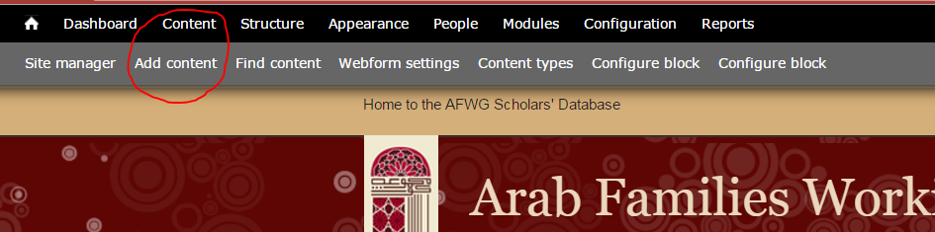

1. Click on the “Content” tab in the upper left hand corner of the page.
2. On the upper left hand corner of the ensuing pop up module, click on the option “+ Add content” link.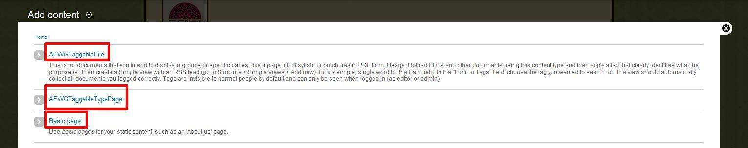
3. Click on the first option of the list, “AFWGTaggableFile”
4. This will allow you to upload the file. This file will be added to the website as a Drupal “Node”, quite similar to a floating block of memory. This node where the pdf is uploaded has its own separate URL and internal pathways.
5. When going to link to the pdf, one can just use the link option in the internal editor. One can either copy and paste the url or the node containing the uploaded pdf into the external link option, or navigate from the internal link option to the desired node.

Uploading Files

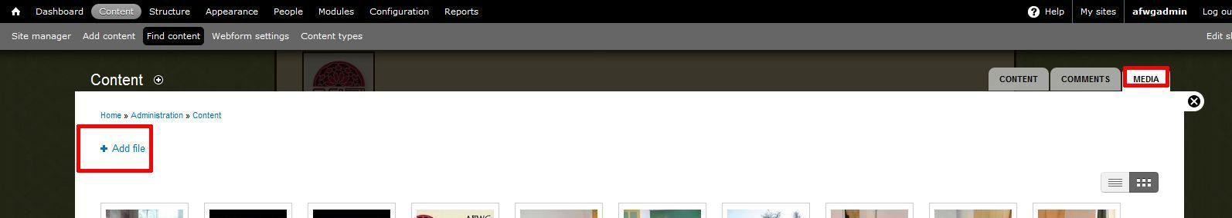

1. Get to the **Find Content** page.
2. Then click on the **Media** tab at the top right, and then **Add File**. Then select files from your computer to upload to the site.
3. Before clicking **Add File**, you should see a list of media.
4. Simply move your mouse over an item to see its URL at the bottom left of your browser. You can copy these URLs for linking purposes.

Menu

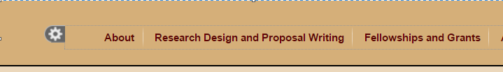

1. Only administrators can edit menus. This is because changing the formatting is risky and can have persistent consequences. The Main Menu is the most important one.
2. While ThemeBuilder (a module we have) is installed:
   1. Move your mouse over any menu.
   2. A gear-shaped icon will appear to the left of that item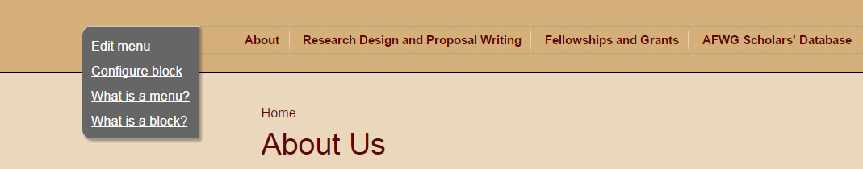
   3. Move your mouse over the gear icon and click **Edit**. Then change titles and nesting for each menu item as desired.

Making Style Changes

1. Click on the “Appearance” tab on the upper left hand corner. Should be the 4th from left option.
2. A new developer module should appear after a short period of time at the bottom third of the page. There should be three options, Front, Borders & Spacing, and Background.
3. From this module, it is remarkably similar to the typical browser inspector tool, where you can select divs and change styles. In the case you need to use something more powerful, click the “advanced” tab and navigate to “Custom CSS”. From here, you can add your own CSS to select classes.